**THIAM, Si Huan Dexter**

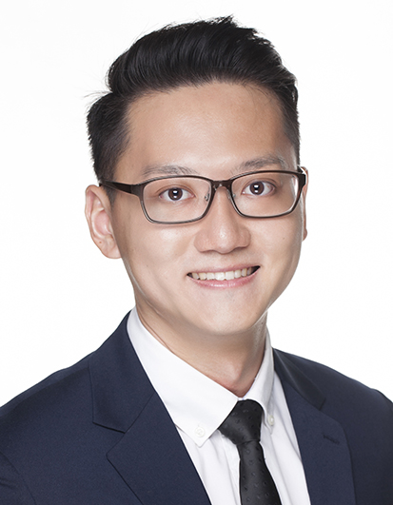to - do not delete/resize this box, but “paste over” leaving a thin grey border. Frame top of head to high chest. High definition quality.

**PERSONAL INFORMATION**

**Nationality:** Malaysian

(Singapore PR)

**Email:**

dexter.sh.thiam@gmail.com

**Mobile:** (+65) 9111 9588

**LANGUAGES**

English (Business)

Mandarin (Native)

Cantonese (Fluent)

Bahasa (Basic)

Japanese (Beginners)

**SUMMARY**

Dexter is graduate with more than 4 years of working experience in the financial service industry, particularly in financial audit and compliance.

He enjoys self-educations and self taught himself basic Japanese, guitar and is currently learning programming.

Other areas of interests include history, economics and policy analysis. Only by studying the course of history can we understand and predict the collective actions of human behavior.

He is also a member of his church's praise and worship team as a guitarist and co-lead singer.

**EDUCATION**

**2008-2011**

**Bachelor Degree**

College of Business and Economics

Australian National University

Australia

**LinkedIn:**

sg.linkedin.com/in/dexter-thiam-9a8a6422

**PROFESSIONAL EXPERIENCE**

**PricewaterhouseCoopers Risk Services Pte. Ltd. Nov 2016-present**

*Senior Associate, Regulatory Advisory Services*

* Internal Audit checks on Asset Management companies on Compliance Monitoring Program, adequacy and completeness of control framework around compliance matters;
* Anti-money laundering audit support testing robustness of firm's AML control on Private Banks.

**Dymon Asia Capital (Singapore) Pte. Ltd. (AUM: USD5bil) Nov 2014-May 2016**

*Compliance Analyst (Asset Management)*

* Assist in developing, drafting and update of compliance policies and procedures, outlining the Firm’s policies, regulations and best practices, in accordance to MAS and HK SFC rules and regulations;
* Assisted in FATCA related work such as gap analysis, remediation and implementation. Not only critical reporting deadlines are met, the reporting costs were also saved by identifying and eliminating unnecessary reporting;
* MAS representative license application and notification update with MAS;
* Staffs' Personal Account Dealing approvals and monthly checks;
* Quarterly checks on AML/KYC documentation on Fund Administrators;
* Liaised with fund managers and traders for pre-trade compliance issues and managed orders efficiently;
* Compile quarterly compliance management report;
* Liaise with auditors during internal audit and resolve audit findings;
* Prepare training materials and contents for internal training.

**PricewaterhouseCoopers, Singapore Dec 2011-Aug 2014**

*Senior Associate 2 in Financial Assurance Audit (Asset Management)*

* Tested internal controls of clients’ operation cycle of different complexity provided insightful knowledge in their business model and learnt about various internal controls which are in place to mitigate/minimize risks;
* Team in charge for a prominent Fund House in Singapore, responsible for review of work on various funds, liaising with Fund Administrators and clients to resolve issues to deliver quality work within tight deadline;
* Audit work involved testing client’s financial risk management disclosure workings, VaR workings and sensitivity analysis;
* Developed an analytical mind through work, analysing revenue and cost drivers, and performed final analytics (trend analytics) review to explain the variances between actual and developed expectation;
* Microsoft Excel skills greatly enhanced through data extraction, compilation and computation in past audit work. Experience of data verification and extraction using Bloomberg Terminal are also available at work;
* Interpersonal and communication skills improvised when dealing with clients as well as managing clients’ expectation.

**PROFESSIONAL CERTIFICATIONS**

**GARP Financial Risk Management - PART I (Passed) Jun 2016**

* Part I covers foundations of risk management concepts, quantitative analysis, financial markets and products, valuations and risk models;

**ADDITIONAL INFORMATION**

**Extra-Curricular Activities**

**Stage performance - 2008**

* Two stage performances of Japanese traditional play in the Street Theatre Canberra;

**Swimming (Malaysian Student's Council of Australia) - 2009**

* Breaststroke 25m Silver medalist and 50m Bronze medalist;

**Interests**

Investing & reading financial news

Reading non-fiction books on politics and economics

Surfing - took lessons in Bali to improve skills